[Date]

Kyer Potts

30003389

Database Programming AT1.3

Hardware Database

1. What is the largest size Aluminium Nut sold by BlackWoods. Display the results in descending order on the Size field.
   1. The largest size of Aluminium Nut by BlackWoods is 55
   2. SELECT \* FROM tblproduct

WHERE `Description` = "Nut" AND `Material` = "Aluminium" AND `Supplier` = "BlackWoods"

ORDER BY `Size` DESC

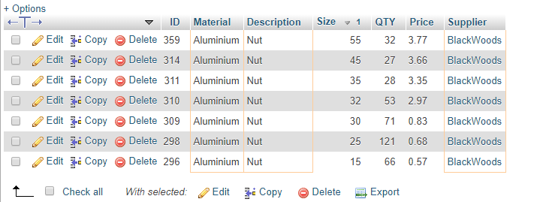

1. What is the cost of 10 Copper 28mm Nut from HG's?
   1. 10 Copper 28mm nuts from HG’s cost $16.50
   2. SELECT price \* 10 FROM tblproduct

WHERE `Description` = "Nut" AND `Material` = "copper" AND `Supplier` = "HG" AND `Size` = 28

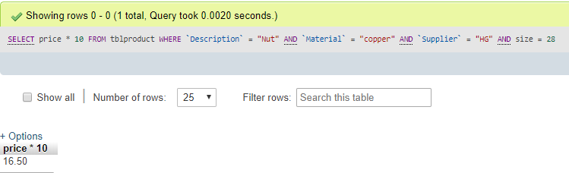

1. How many products have a qty less or equal to 10?
   1. 13 products have a qty less or equal to 10
   2. SELECT COUNT(QTY) FROM tblproduct

WHERE `QTY` <= 10

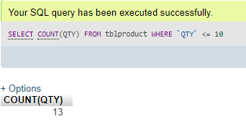

1. How many Suppliers have a name starting with A?
   1. 2 Supplier names begin with A
   2. SELECT COUNT(SupplierName) FROM `tblsupplier`

WHERE `SupplierName` LIKE "A%"

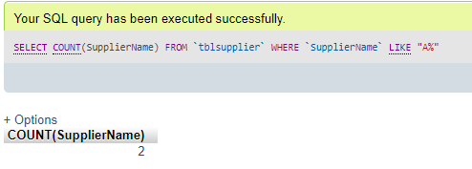

1. How many Nuts and Bolts are made by Avery?
   1. Avery makes 118 bolts and nuts
   2. SELECT COUNT(ID) FROM `tblproduct`

WHERE `Supplier` = "Avery" AND (`Description` = "Bolt" OR `Description` = "Nut")

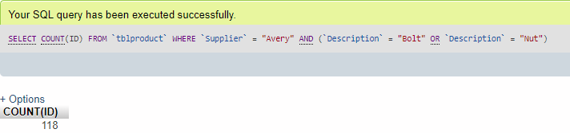

1. How many items are made of Copper?
   1. 72 items are made of copper
   2. SELECT COUNT(ID) FROM `tblproduct`

WHERE `Material` = "Copper"

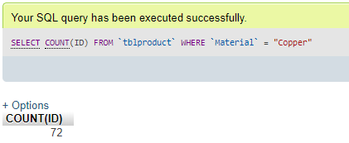

1. What is the Average cost of 28mm Steel Bolts
   1. The average price of 28mm steel bolts is $3.97.5
   2. SELECT AVG(`Price`) FROM `tblproduct`

WHERE `Material` = "Steel" AND `Size` = 28 AND `Description` = "Bolt"

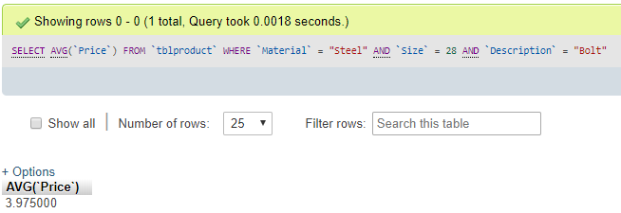

1. Which manufacturer has the most 10mm washers, display the results in descending order on the qty field.
   1. Acme has the most 10mm washers
   2. SELECT \* FROM `tblproduct`

WHERE `Size` = 10 AND `Description` = "Washer"

ORDER BY `QTY` DESC

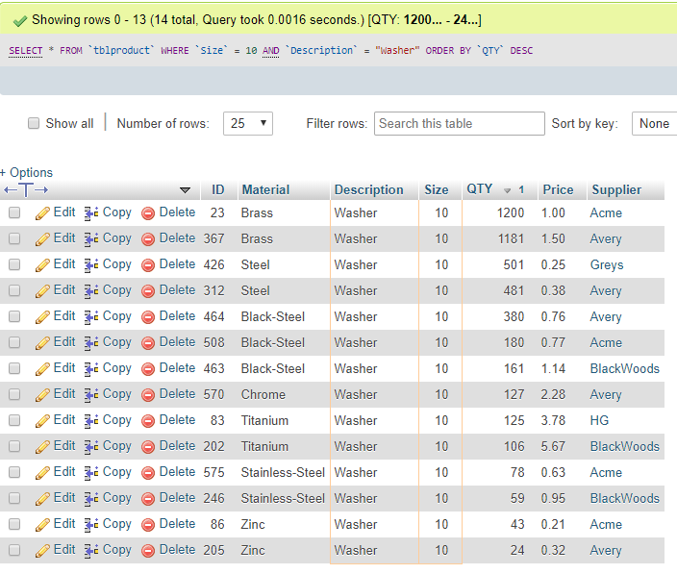

1. Who makes the cheapest 10mm Black-Steel Bolts, display the results in descending order on the Price field.
   1. Avery makes the cheapest 10mm black-steel bolts
   2. SELECT \* FROM `tblproduct`

WHERE `Size` = 10 AND `Description` = "Bolt" AND `Material` = "Black-Steel"

ORDER BY `Price` ASC

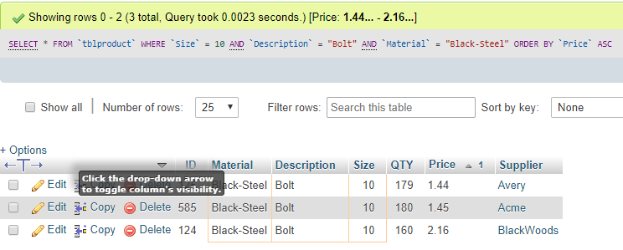

1. Who makes the cheapest 10mm Bolts, display the results in ascending order on the Price field?
   1. Greys makes the cheapest 10mm bolts
   2. SELECT \* FROM `tblproduct`

WHERE `Size` = 10 AND `Description` = "Bolt"

ORDER BY `Price` ASC

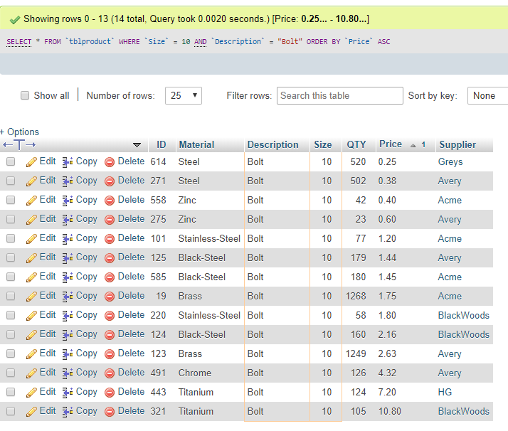

1. How many manufacturers make 20mm products (Hint use DISTINCT)
   1. 5 suppliers make 20mm products
   2. SELECT COUNT(DISTINCT(`Supplier`)) FROM `tblproduct`

WHERE `Size` = 20

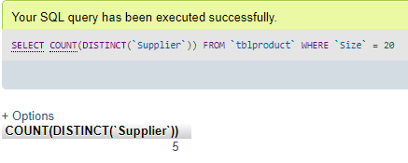

1. What is the price of Plastic 15mm Bolts?
   1. Widget sells plastic 15mm bolts for $0.29 and BlackWoods sell them for $0.42
   2. SELECT \* FROM `tblproduct`

WHERE `Size` = 15 AND `Material` = "Plastic" AND `Description` = "Bolt"

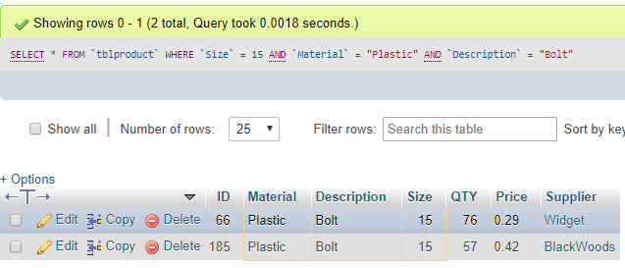

1. What is the Average cost of 35mm Brass Washers?
   1. The average price of 35mm brass washers is $1.94
   2. SELECT AVG(`Price`) FROM `tblproduct`

WHERE `Size` = 35 AND `Material` = "Brass" AND `Description` = "Washer"  
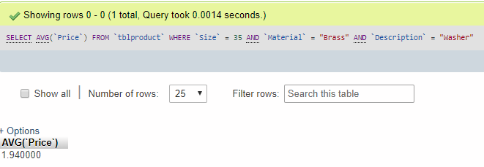

1. Can I buy 1500 10mm brass nuts? What is the cheapest price? How many items are in stock?
   1. Yes you can buy $1500 at different prices. Avery sells them cheapest. There are 2481 items in stock from all suppliers.
   2. SELECT \* FROM `tblproduct`

WHERE `Size` = 10 AND `Material` = "Brass" AND `Description` = "Nut"  
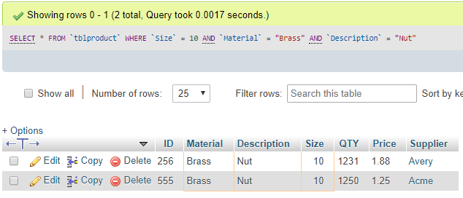

1. How many manufactures make 35mm steel products (any type of steel)?
   1. 4 manufacturers make 35 mm steel products
   2. SELECT COUNT(DISTINCT(`Supplier`)) FROM `tblproduct`

WHERE `Size` = 35 AND `Material` LIKE "%steel%"

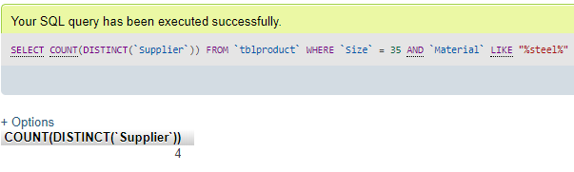

1. What is the price of Copper 28mm Bolts?
   1. HG sells for $2.65 and BlackWoods sells for $3.98
   2. SELECT \* FROM `tblproduct`

WHERE `Size` = 28 AND `Material` = "Copper" AND `Description` = "Bolt"  
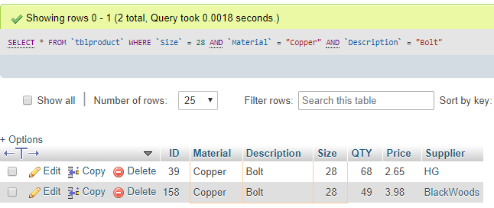

1. . Which is cheaper 45mm or 55mm Brass Bolt from Avery (Hint use BETWEEN)? Display the results in ascending order on the Price field.
   1. The 55mm bolts are cheaper
   2. SELECT \* FROM `tblproduct`

WHERE `Size` BETWEEN 45 AND 55 AND `Material` = "Brass" AND `Description` = "Bolt" AND `Supplier` = "Avery"  
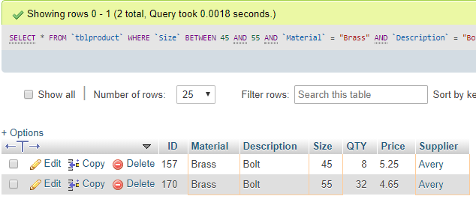

1. Can I purchase 700 25mm Black-Steel Nuts? Explain. (Hint use SUM)
   1. Yes there are 754 available
   2. SELECT SUM(`QTY`) FROM `tblproduct`

WHERE `Size` = 25 AND `Material` = "Black-Steel" AND `Description` = "Nut"

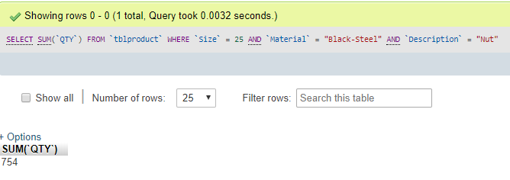

1. What is the cost of 23 Aluminium 80mm Nuts?
   1. $169.28
   2. SELECT `Price` \* 23 FROM `tblproduct`

WHERE `Size` = 80 AND `Material` = "Aluminium" AND `Description` = "Nut"  
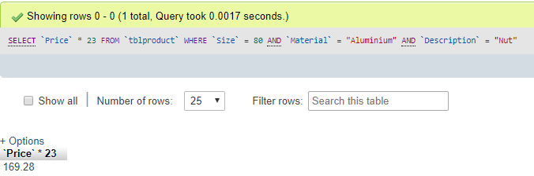

1. . List all the suppliers who are located in a suburb beginning with "C"
   1. Greys and Widget come from a suburb beginning with “C”
   2. SELECT \* FROM `tblsupplier`

WHERE `Suburb` LIKE "C%"  
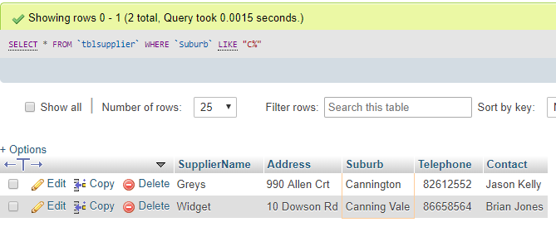

1. . List all the Zinc products where the contact is Sue Harris, display results ascending order on the Size field
   1. SELECT \* FROM tblproduct

INNER JOIN tblsupplier ON tblproduct.Supplier = tblsupplier.SupplierName

WHERE `Material` LIKE "%Zinc%" AND Contact = "Sue Harris"

ORDER BY `Size` ASC  
